**Walkthrough - School**

Contents

Host Discovery 2

Nmap 2

Nikto 2

Dirb 3

Sub-dir found 3

SQL File Analysis 3

CrackStation 4

Viewing Website 4

Exploitation 4

Upgrading Shell 5

Finding binaries 6

Root Directory 6

MYSQL 7

# Host Discovery

**Kali Machine**: 192.168.56.101/24.

**Victim**: 192.168.56.136/24.

# Nmap



I tried an aggressive approach with this one, however this means I can easily be discovered.

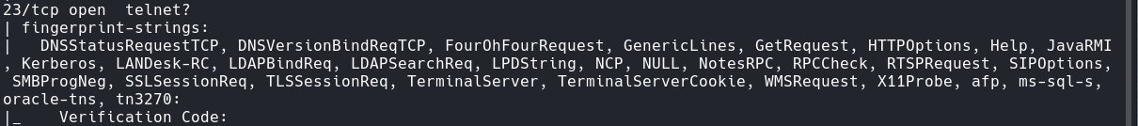

# Nikto





There are the interesting items found by nikto.

# Dirb





This database directory was found.

## Sub-dir found



# SQL File Analysis

Downloading and opening the file shows table creation and data insertion.

Got some server information

Table Information





Found some valuable information.

(1, 'Administrator', 'admin', '0192023a7bbd73250516f069df18b500', 1, 0),

(2, 'John Smith', 'jsmith@sample.com', 'af606ddc433ae6471f104872585cf880', 3, 1);

Students:

(1, '06232014', 2, 'Claire Blake', '2020-10-28 11:53:24'),

(2, '123456', 2, 'George Wilson', '2020-10-28 15:20:57');

# CrackStation

Now its time to crack the hashes. I will use crackstation to decode and hash-identifier to determine the hash.



Admin

John

The admin credentials allow me to login to the student login page.

# Viewing Website

Enter the credentials here.



# Exploitation

Since we are greeted with the welcome back admin page, we can inspect the source code to see anything unusual or hints.

This is a very interesting line. I will take the href link. (‘index.php?page=site_settings’)

Now this allows a file to be uploaded.

I quickly set up a netcat:

Once I filled out the form, I then uploaded pentest monkeys reverse_shell.php with the port 9999 and address of my kali machine.

## Upgrading Shell



Looking through the home directory I see two directories.

Going into fox reveals a text file: local.txt.

I believe this may be the first flag. (*e4ed03b4852906b6cb716fc6ce0f9fd5*)

## Finding binaries

# Root Directory

There is the flag and a win binary.

Since strings wasn’t found command, I used cat and found this.

I don’t know if its important, but I’ll keep looking. Next I ‘ll go to /var/www/html/student…/.

There are many php files listed.

There is a file here called ‘db_connect’ which sounds interesting.

$conn= new mysqli('localhost','fox','trallalleropititumpa','student_attendance_db')

This appears to be credentials for the database student_attendance.

# MYSQL

LEFT INCOMPLETE – ITS ADVANCED!